**PROJECT TOPIC: Recommendation of Skin Cancer Severity**

**CSE-AIML Group No.:** 29

**Project Group Members:**

1. Archie Gaur (201550035)
2. Pradhumn Agrawal (201550099)
3. Rishabh Tiwari (201550115)
4. Sudeep Jain (201550133)

**Project Supervisor:** Mr. Rishi Agrawal, Assistant Professor

**Objective:** The objective of this project is to develop an Android app and web application that can recommend the severity of skin cancer. The aim is to provide users with real-time, accurate assessments of their skin condition based on uploaded images. The applications are designed to raise awareness, promote early detection, and facilitate timely medical intervention. Ultimately, the goal is to improve patient outcomes through informed decision-making.

**Tools required:**

* **Hardware Requirements:**
* **Processor**: Intel Core i5 or higher is recommended (for android application) and a quad-core i3 or i5 processor with a speed of at least 2GHz is recommended (for web application).
* **Memory (RAM):** Minimum of 4GB, but 8GB or more is highly recommended (for both android app and web application).
* **Storage:** 128GB or more is recommended. SSDs are preferred for faster read/write speeds.
* **Operating System:**  A 64-bit system is required.
* **Screen Resolution**: 1920x1080 or higher is recommended for better visibility.
* **Software Requirements:**
* Android Studio
* Java (used in Android app development)
* Android SDK
* Web Browser
* Python 3.9 (& libraries)
* Web Development Languages (HTML, CSS, JavaScript)
* Text Editor (PyCharm , Jupyter Notebook)
* Flask

**Abstract:** This study uses deep learning for classifying dermatological images, focusing on melanoma detection. A dataset of clinical images is assembled and preprocessed, then split into training and testing subsets. The VGG16 model is trained to distinguish melanoma images and estimate cancer likelihood. The model’s performance is evaluated on a separate validation dataset. User-friendly web and mobile applications are developed based on the trained model, providing real-time diagnosis, melanoma information, remote consultations, and contributing to dermatological research. The goal is to democratize melanoma diagnosis, improve early detection, and enhance patient outcomes.

**Outcome:**

Android Application

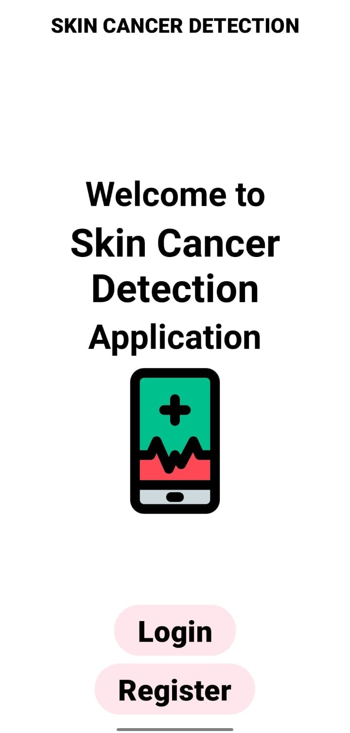 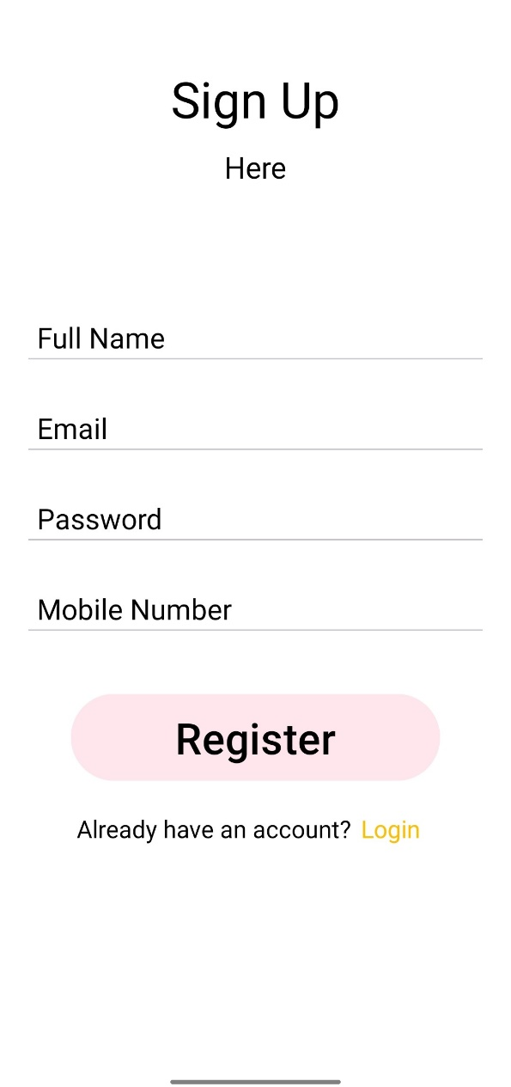

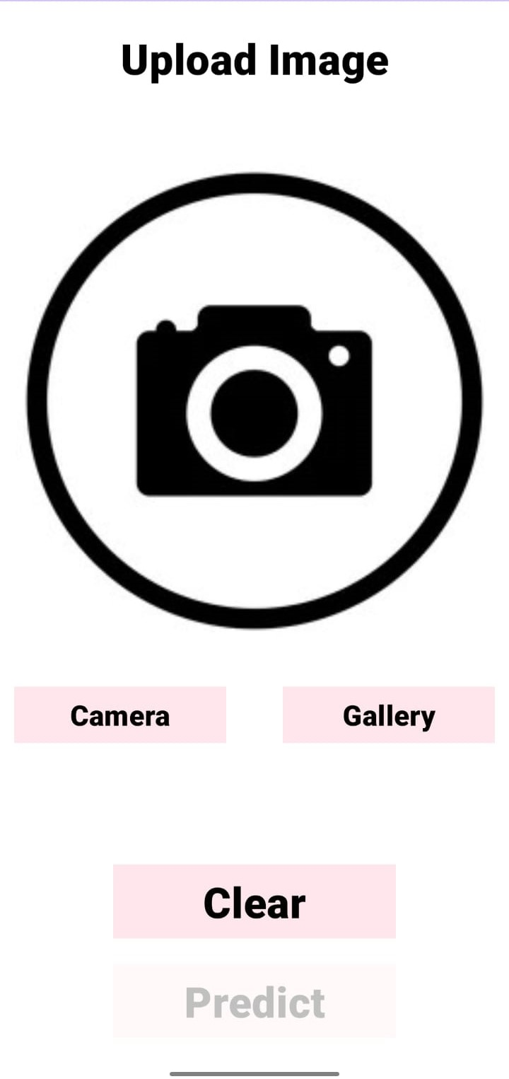 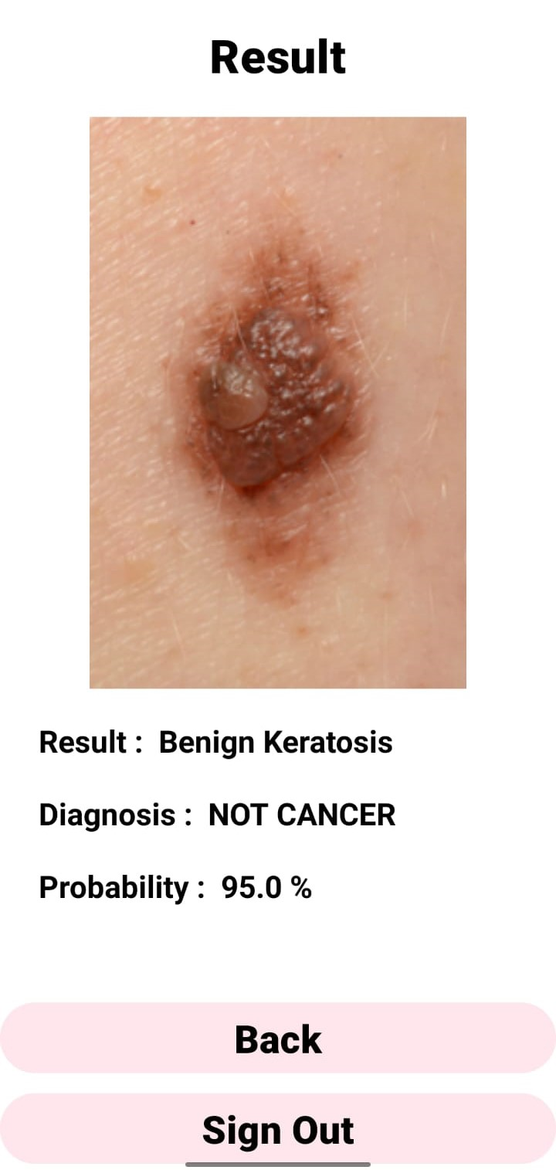

Web Application

